Practical No 5

NAME OF STUDENT: PREMRAJ SAKURE
SUBJECT: WEB DEVELOPMENT
SESSION: 2025-2026
CLASS: MCA SEM 1

Aim: Implement a responsive navigation bar with dropdowns using Bootstrap.

Source-Code:
<!DOCTYPE html>
<html>
<head>
<title>Bootstrap Example</title>
<meta charset="utf-8">
<meta name="viewport" content="width=device-width, initial-scale=1">
<link href="https://cdn.jsdelivr.net/npm/bootstrap@5.3.3/dist/css/bootstrap.min.css" rel="stylesheet">
<script src="https://cdn.jsdelivr.net/npm/bootstrap@5.3.3/dist/js/bootstrap.bundle.min.js"></script>
<style>
body {
background-image: url('https://4kwallpapers.com/images/walls/thumbs_3t/24770.jpg');
background-size: cover;
background-position: center;
background-repeat: no-repeat;
height: 100vh;
}
</style>
</head>
<body>
<header class="bg-light text-dark text-center py-3">
<h1>Welcome to My Website</h1>
<h5>Your one-stop solution for all things web!</h5>
</header>
<nav class="navbar navbar-expand-lg navbar-dark bg-dark">
<div class="container-fluid">
<a class="navbar-brand" href="#">Navigate through the website</a>
<button class="navbar-toggler" type="button" data-bs-toggle="collapse"
data-bs-target="#navbarNavDropdown" aria-controls="navbarNavDropdown"
aria-expanded="false" aria-label="Toggle navigation">
<span class="navbar-toggler-icon"></span>
</button>
<div class="collapse navbar-collapse" id="navbarNavDropdown">
<ul class="navbar-nav ms-auto">
<li class="nav-item">
<a class="nav-link active" href="#">Home</a>
</li>
<li class="nav-item">
<a class="nav-link" href="#">Services</a>
</li>
<li class="nav-item dropdown">
<a class="nav-link dropdown-toggle" href="#" id="navbarDropdown"
role="button" data-bs-toggle="dropdown" aria-expanded="false">
More
</a>
<ul class="dropdown-menu dropdown-menu-end" aria-labelledby="navbarDropdown">
<li><a class="dropdown-item" href="#">Contact</a></li>
<li><a class="dropdown-item" href="#">Blog</a></li>
<li><a class="dropdown-item" href="#">Careers</a></li>
</ul>
</li>
</ul>
</div>
</div>
</nav>
<div class="container mt-4">
<div class="p-5 bg-dark text-light rounded">
<h2>About Us</h2>
<p>We are dedicated to providing the best web solutions for our clients. Our team of experts works tirelessly to ensure customer satisfaction and deliver top-notch services.</p>
</div>
<div class="p-5 bg-dark text-light rounded mt-4">
<h2>Our Services</h2>
<ul>
<li>Web Development</li>
<li>UI/UX Design</li>
<li>Digital Marketing</li>
<li>SEO Optimization</li>
</ul>
</div>
</div>
</body>
</html>

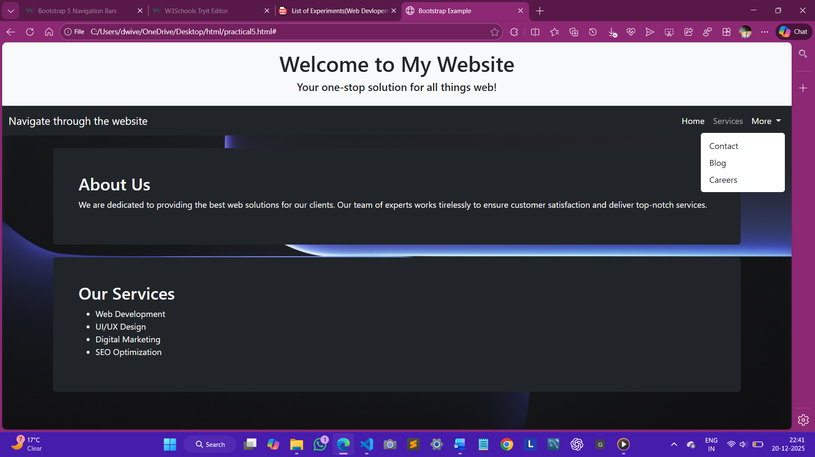
Output:

